# Analysis Services Assignment:

## Your project, data sources, data source views and cubes should have a prefix with your firstname three letter initials (e.g. rajWWIDW, rajCustomer, rajWWICube etc.

You r submission should contain the url for your source code in Visual Studio Team Services and screen shots as outlined in this document.

1. Use the Wide World Importers DW database
2. You need to build a cube with the following measure groups:
   1. Sales – Sales Quantity, Sales Total, Sales Profit
   2. Order – Order Quantity, Unit Price, Order Total excluding Tax, Order Count
   3. Purchase – Ordered Purchase Quantity, Ordered Purchase Outers, Received Purchase Outers
3. Use the following Dimensions and match the dimensions with the appropriate measure groups
   1. Date (Delivery Date, Order Date, Received Date, Invoice Date), Customer, Stock Item, Bill To Customer, City, Employee
   2. Use named query (not named calculation to build the Date Dimension with the following attributes: Month year key, Month year, Quarter Number, Quarter year Key, Quarter, Year Quarter, Beginning of Quarter and Beginning of Month: 201301, Jan 2013, 1, 20131, Q1, 2013-Q1 , 2013-1-1, 2013-1-1
   3. Build the Dimensions and hierarchies

## Date

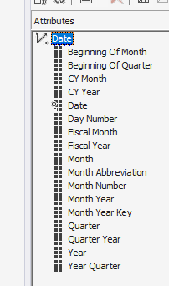

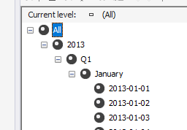

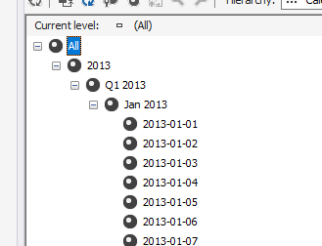

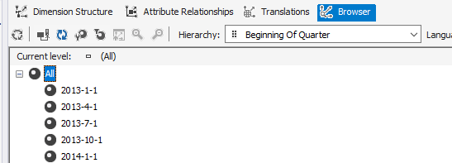

## City

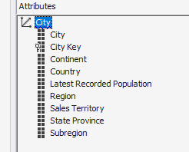

Geography- Hierarchy

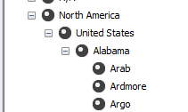

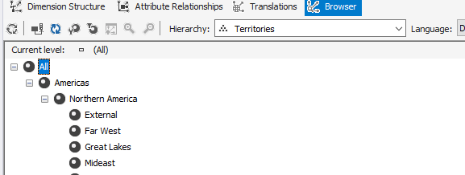

## Stock Item

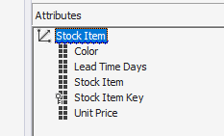

## Employee

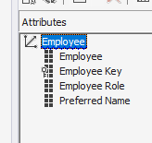

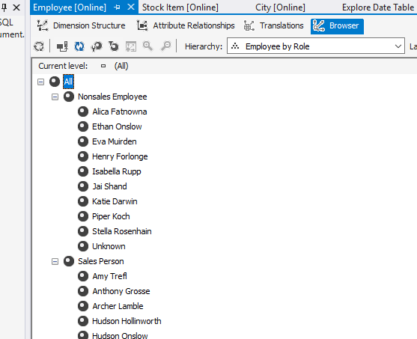

## Customer

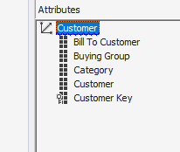

Billing Hierarchy

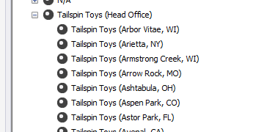

1. Your Dimension usage should look like this

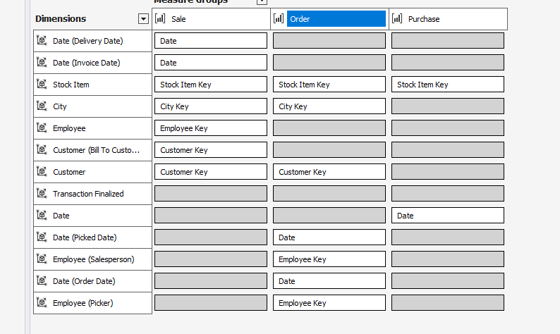

1. Do the following calculations

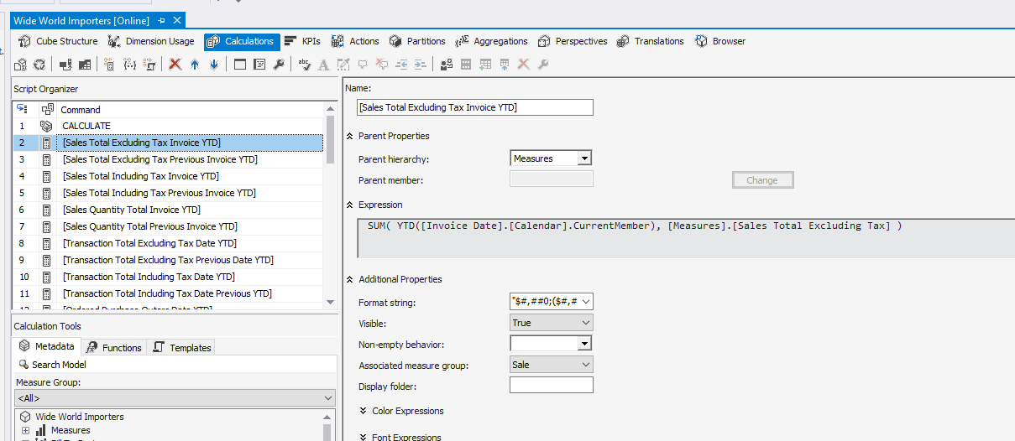:

1. Deploy your cube and provide screen shots of the following:

Order

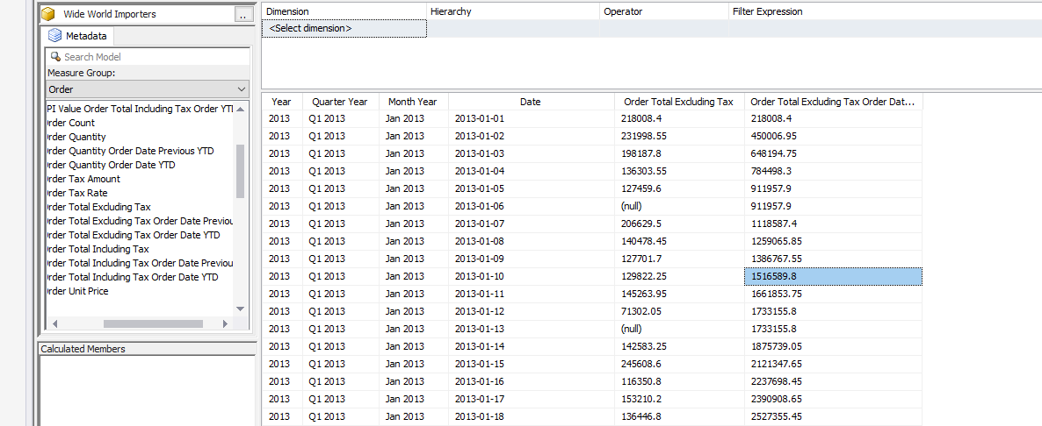

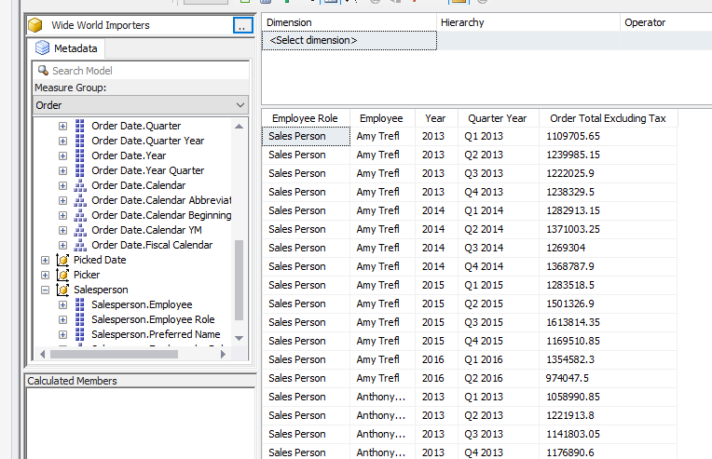

Sales

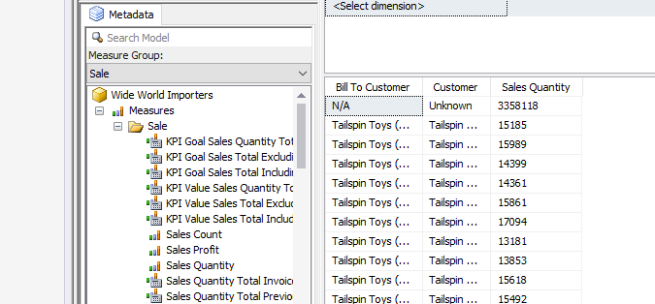

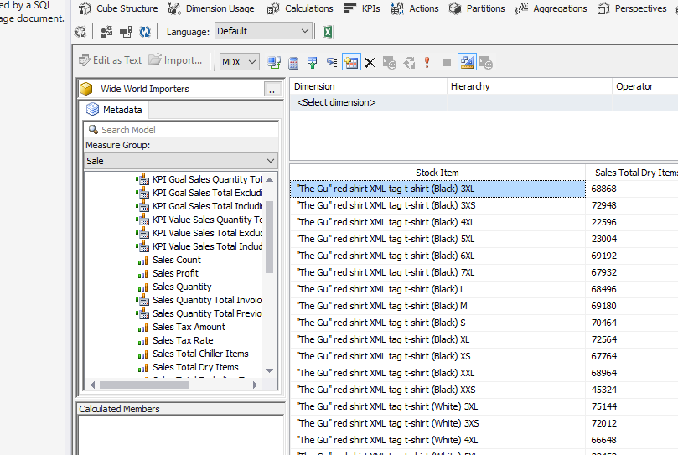

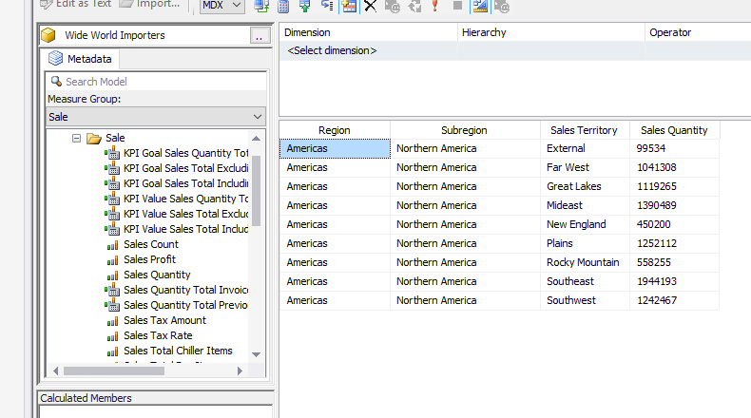

Purchase

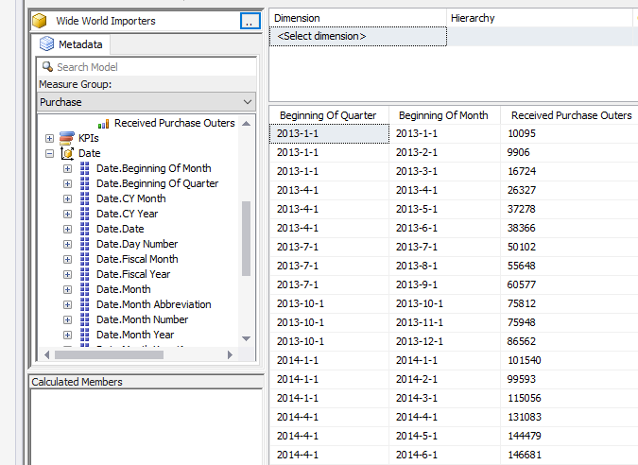

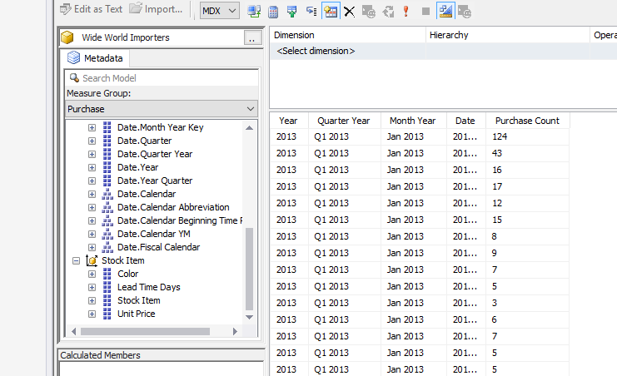

Part 2

Build a Power BI dashboard using your DW as the data source

Use this Query

SELECT Customer, D.Date, Location.Lat as Latitude, Location.Long as Longitude, SUM([Total Excluding Tax]) AS [Total Excluding Tax], SUM([Total Including Tax]) AS [Total Including Tax], SUM(Profit) AS Profit, Employee AS SalesPerson

FROM Fact.Sale S JOIN Dimension.Customer C ON S.[Customer Key] = C.[Customer Key]

JOIN Dimension.Employee E ON S.[Salesperson Key] = E.[Employee Key]

JOIN Dimension.City Ci on S.[City Key]=Ci.[City Key]

JOIN Dimension.Date D ON S.[Invoice Date Key]=D.Date

GROUP BY Customer, D.Date, Location.Lat, Location.Long, Employee

As a minimum have these charts

With Profit using Sales person as legend and time in X axis

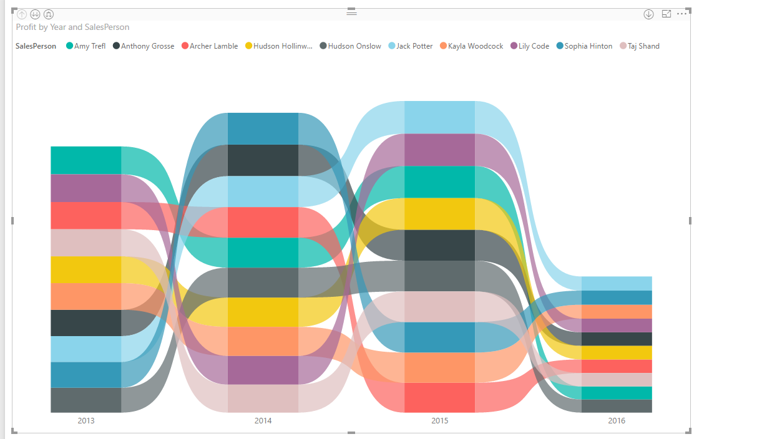

A funnel chart with decreasing sales by Sales person

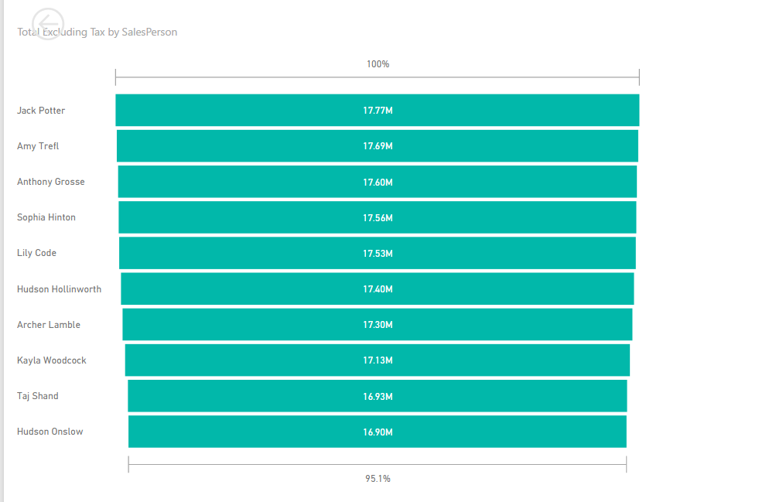

A drill through charts that dispays profit in tooltips

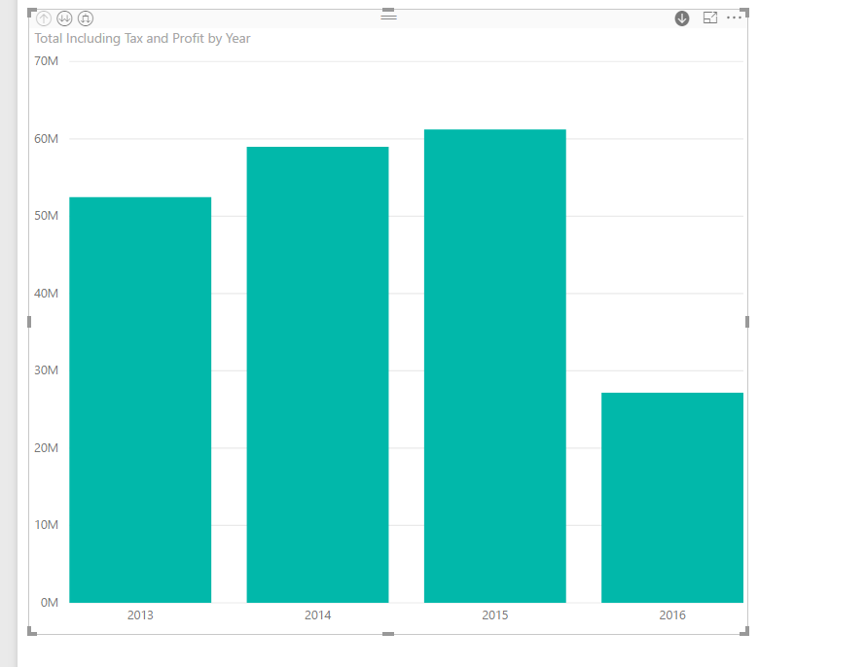

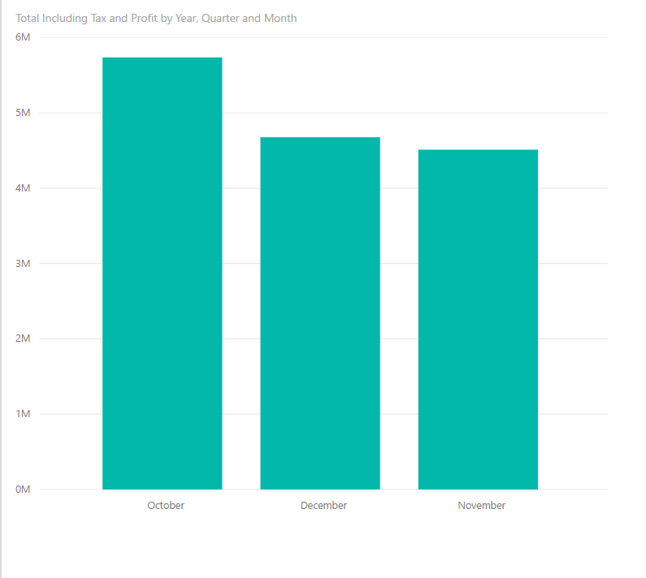

Fix the order of display so that it is October, November and December by editing query.